
Gilbertstone Primary School
Attendance Policy

AIMS
We aim to work in partnership with parents and the Local Authority to ensure high levels of attendance so as to impact positively on pupil well-being and outcomes. We follow Birmingham City Council’s ‘Support First’ attendance framework and guidance. This ensures that school and parents meet their legal requirements.

THE IMPORTANCE OF SCHOOL ATTENDANCE
School attendance is not just a legal requirement but an important to secure a good education. Good attendance promotes academic success and personal growth, which will enhance better prospects, making it an important aspect of any educational system.

- Academic Achievement: Regular attendance directly impacts on academic success. Children who attend school consistently are more likely to keep up with the curriculum, perform better in exams, and improve their life outcomes.
- Knowledge Acquisition: School is where children acquire knowledge and skills that are crucial for their personal and professional growth. Missing days means missing out on valuable learning opportunities.
- Social Development: School provides a vital social environment for children to interact with peers, develop friendships, and learn essential social skills. Consistent attendance ensures children remain connected to their peer group.
- Building Routine: School attendance establishes a structured routine in children’s lives, teaching them time management and responsibility, which are valuable life skills.
- Teacher Interaction: Regular attendance allows for meaningful teacher-child interactions. Teachers can provide personalised support, address questions, and assess individual progress more effectively when children attend regularly.
- Preventing Knowledge Gaps: Frequent absences can lead to significant knowledge gaps, making it challenging for children to catch up with missed lessons, potentially resulting in long-term academic struggles.
- School Engagement: Children who attend school regularly are more likely to engage in extracurricular activities, sports, and other enriching experiences that contribute to their overall development.
- Legal and Parental Responsibility: Parents or guardians are legally responsible for ensuring their child's regular school attendance. Failing to do so can lead to legal consequences.
- Community Well-being: High levels of school attendance contribute to the overall well-being of communities.

1.WORKING IN PARTNERSHIP WITH PARENTS
Gilbertstone Primary School recognises that poor attendance is often an indication of difficulties in a child’s life and their lived experience. This may be related to problems at home or in school. Parents should inform the school of any difficulties or changes in circumstances that may affect their child’s attendance and or behaviour in school, for example, bereavement, divorce/separation, incidents of domestic abuse. This will help the school to identify any additional early help that may be required.
Safeguarding is a priority, concerns for any child at any time will be reported to the Designated Senior Leads for Child Protection. We will always follow Keeping Children Safe in Education 2024 and our Child Protection Policy.

Some pupils are more likely to require additional support to attain good attendance, for example, pupils who are vulnerable, have a medical need or EHCP and will be monitored and supported closely in school.

2. ROLES AND RESPONSIBILITIES
In order to meet these requirements:

2.1.Parents will:

The term ‘parent’ includes those who are not a natural parent but have parental responsibility for the child as defined by the Pupils’ Act 1989 or have care of the child as defined by the Education Act 1996.

- understand they have a legal responsibility to ensure their children receive appropriate education (failing to send their child to school regularly without good reason is a criminal offence).
- provide at least 2 emergency contact numbers to support school in their safeguarding procedures. Any changes to these numbers should be communicated with school immediately
- receive an attendance letter on procedures for attendance and lateness including the whole school letter from the Local Authority.
- ensure children are dropped off and picked up on time (gates for KS1/Early Years and KS2 will be opened at 8.35am for drop off and 3.15pm for collection)
- inform school of a reason for any late arrival and late pick up
- understand that if their child has not been collected, and it has not been possible to contact a parent or named carer, 1 hour after the agreed finish time for the school day/activity, a phone call will be made to the Multi-Agency Safeguarding Hub (MASH) and the Emergency Procedures for non-collection will be followed
- inform the school by 9am on the first day of any reason for their child’s absence, and each day after to update.
- give clear reasons for absence including any symptoms of illness.
(Parents will receive a text message to the primary contact if no reason for absence is given by 9am)
- always try to arrange for medical appointments or treatments outside of the school day
- request permission in advance from the Head Teacher if a child needs to have appointments within the school day (via the school office) and if possible provide evidence of these appointments.
- request permission from the Head Teacher for leave for exceptional circumstances during term time by completing the Leave of Absence Request Form
- encourage children to discuss with staff any difficulties they may be experiencing which is affecting their attendance
- not request holiday in term time

2.2 School will:
- communicate school start and finish times and any school closure dates through school publications and the school website.
- keep attendance and admission registers.
- make daily contact with alternative provision in the case of children who are dual registered to ensure they are in attendance.
- contact parents where there is a concern about attendance or punctuality at the earliest opportunity.
- monitor levels of attendance on a weekly basis.
- follow the Right Help Right Time Early Help offer to support families.
- encourage children to have high expectations in attendance.
- make a referral in line with Birmingham city Council’s CME guidelines (Child Missing from Education) if school cannot establish the safe whereabouts of a child.
- make a referral to CASS (Children’s Advice and Support Service) or the police if there is a serious concern for a child’s safety.
- seek advice and initiate a referral to the ELIT (Education and Legal Intervention Team), which can result in a penalty notice being issued or a court case.
- identify children at risk of being persistently absent at the earliest opportunity and follow the ‘Support First’ framework.
- contact the LA before taking a child off roll.
- invite parents to use the Scholar Pack app to monitor their own child’s attendance daily.

2.3.School’s Attendance Lead (Mrs Hoo) will:

- establish open lines of communication and a supportive ethos around attendance with parents
- be the attendance liaison person for the Support First framework, ensuring that relevant levels of intervention take place, referrals are made, and attendance meetings are set up, in line with the guidance.
- contact parents/carers, as a duty of care in line with our safeguarding policies
- be proactive in partnerships with parents and other agencies regarding the attendance and well- being of the children.
- liaise with Learning Mentors and SENDCo to monitor attendance concerns
- liaise with Senior Office Manager to ensure accurate coding is used in line with Local Authority guidelines.
- use attendance data to make links with academic performance
- monitor and track attendance of vulnerable groups
- create a termly attendance report to share with the Governing Body analysing attendance data across school.
- make referrals to outside agencies, to address any unmet needs, that can impact positively on attendance.
- identify children that need to be placed on the vulnerable list for attendance.
- report on progress and next steps for these vulnerable children during children’s team meetings
- provide training and support to staff
- communicate with class teachers and phase Leaders about children at risk of being persistently absent and involve them in the supportive process.
- refer and follow local authority guidelines around part-time and reduced timetables.
- ensure that contact is maintained with any pupil on a long-term absence and carefully plan any transition into school.

Mrs Hoo can be contacted through attendance @gilbertstone.bham.sch.uk.

2.4 The Head Teacher will:
- decide when an absence is authorised
- report to the FGB via the HT Report the up-to-date attendance outlook at every meeting
- share responsibility with the Governing Body to ensure that the relevant laws and guidelines concerning attendance are followed
- ensure that rigorous and robust safeguarding policies and procedures are in place.
- liaise closely with the attendance lead to ensure that all statutory and legal duties are followed
- monitor the implementation and impact of any strategic developments around attendance

Absence can only be authorised by the Head Teacher, within the boundaries set by the Education (Pupil Registrations) (England) Regulations 2006. The Head Teacher
may not authorise leave during term time except where the circumstances are exceptional.

2.5.Teachers will:
- provide a good example by always being punctual to registration, meeting pupils at the door and providing a welcoming and inclusive environment
- build a welcoming atmosphere and provide support as necessary when pupils return after absence.
- provide well planned and engaging lessons.
- accurately mark registers at 8.45am for the morning session and 1pm in the afternoon session, as required by the School Teacher’s Pay and Conditions Document and be aware of school policy and procedures around this legal process.
- refer any absences and causes for concern to the attendance lead immediately
- refer any requests for leave in term time to the attendance lead or Senior Office Manager
- encourage and motivate school attendance to ensure that pupils are aware of the benefits of being in school e.g., academic success, making friends, curriculum enjoyment

2.6.The Senior Office Manager will:
- ensure accurate coding on school registers
- liaise with the Learning Mentors regarding first day absence and any concerns
- send a text message to parents and record on Scholar Pack
- ensure that all letters, notes and messages from parents/carers regarding absences are recorded on Scholar Pack
- ensure that office staff log any children who leave or enter during the day, in case of a fire, and log their departure in the designated book.
- ensure reasons for absence and lateness are filled in as soon as they are known
- print attendance registers for the fire safety procedures after the close of register in the morning. This is manually updated to reflect any ins/outs of pupils.
- alert the attendance lead if any vulnerable children are missing or there is any unexplained absence.
- create and communicate relevant framework letters to parents, as directed by attendance lead

2.7.The Learning Mentor will:
- monitor absence and late marks, identifying patterns and linking with parents and the attendance lead, to support improvement
- make first day calls or home visits as necessary and where appropriate, and update Scholar Pack accordingly, recording reasons for lateness or absence
- support children when there is an issue which prevents children from attending school regularly.
- offer Early Help, sign posting and referrals to outside agencies.
- to illicit pupil voice with regards to specific individual pupil attendance

2.8 Governors will:
- agree a policy for attendance
- ensure the policy is implemented and monitored on a regular basis
- have a named Governor for attendance who will come in and meet with attendance lead and report back to the FGB regularly.
- reflect on the data that is shared and make appropriate and relevant challenge.

3. IDENTIFYING ATTENDANCE CONCERNS
Through regular monitoring, attendance concerns are identified, so that parents can engage with school and take up any support offered to prevent their child from becoming persistently absent (19 days absence or more /below 90%) or severely absent (below 50%).
Each situation will be dealt with on an individual basis, fairly and equitably, always remembering the welfare and safety of the child is the paramount concern.

3.1.Support First school famework and guidance (in liaison with the Education Legal Intervention Team)

School will follow the support First flow chart, referring to the full guidance for further detail.

Concerning levels of pupil absence either authorised or unauthorised

Facilitate Support
–

Early help
-

capturing the voice of the child, completing Section 7 of the Early
Help Assessment form with the parents/carers in an informal meeting (if there is consent and
engagement).
(
If a social worker/family support/early help worker is already involved there is
no need to offer Early Help but capturing the voice of the child is still required)
.

At least one session of unauthorised absence

Formalise Support

–

Invite parents/carers to a Formal Attendance Meeting (FAM)

using the
Invitation to a FAM letter

and hold the FAM. Complete a
n

attendance contract if the parents
attend.
Do not move to this step unless
the ‘Facilitate Support’ stage
has been completed
,
including capturing the voice of the child and offering early help
.

Outcome A

-

If parents do not attend

or
respond

rearrange the FAM by sending a
‘rearranged FAM’ letter.

If they still do not
attend, send parents the DNA FAM letter.

Outcome B

-

If parents attend, send parents
the post FAM letter with a copy of the
agreed formal attendance contract.

Revisit
the contract if required and extend the
contract term as appropriate

The pupil has
10

further
sessions of
unauthorised absence
from at least one day after
the
date the
attendance contract was signed

within a maximum 10 school week period
.

Revisit the contract if
required and extend the contract term if appropriate.

Enforce
-

Refer

to ELIT via online form as soon as the child has 10 sessions of
unauthorised
absence

after the FAM
.

Do not move to this step if there has been no further unauthorised
absence within 10 school weeks of the FAM being held.

Outcome
A

If approved by ELIT, school to issue Notice
to Improve to parents

Outcome
B

Penalty Notices
/Legal proceedings

issued
to parents

week
6

attendance
monitoring period.
Provide attendance
update to ELIT.

Outcome
A

If
there is no unauthorised absence in the 6
weeks, no
further action.

Outcome
B

If
there is further unauthorised absence,
Penalty Notices
/Legal Proceedings

issued
to parents
.

4. LEAVE IN TERM TIME:
- Parents must request permission from the Head Teacher for leave during term time by completing the Leave of Absence Request Form including a date for the child’s return to school.
- If travelling abroad, parents should supply a copy of the return travel documentation and supply the name and phone number of a contact person.
- Parents may be issued with a penalty notice. If they do not pay the fine, the case may be referred to Court which could result in a fine of up to £1000 per child and a criminal record.
- In exceptional circumstances, or for repeat offences, penalty notices may not be issued, and cases may be referred straight to Court.
- If the absence is not authorised then the LD1 letter will be issued
- If no written request was made then the LD2 letter will be sent.
- If there are 10 continuous sessions/ 5 days (1 session is the equivalent to half a day) of unauthorised leave during term time, then a referral is made to the Educational Legal Intervention Team.
- If a child fails to return and contact with the parent has not been made or received, school may take the child off the school’s roll in compliance with the Education (Pupil registration, England) Regulations 2006. This means that the child may lose their school place.

5. LEGAL SANCTIONS
Penalty Notices will be considered when:
- a child is absent from school for the purpose of a Leave of Absence in term time and the absence has not been authorised by the school.
- a child has accumulated at least ten sessions of unauthorised absence and further absence has occurred following written warning to improve

5.1 Prosecution
Where intervention through the school’s process fails to bring about an improvement in attendance, the local authority will be notified and legal proceedings in the Magistrates Court may be taken. The school will provide the Local Authority with evidence required for a prosecution under section 444/4441 (a) of the Education Act 1996 and will appear as a prosecution witness if required by the court. This is to ensure that parents realise their own responsibilities in ensuring their child’s attendance at school.

Penalty notices are fines issued to parents for unauthorised school absences, with a national threshold of 10 sessions (5 days) within 10 school weeks, and escalating consequences for repeat offences.
When a Penalty Notice is Issued
A penalty notice, often referred to as a fine, can be issued to parents if their child has unauthorised absences from school. Under the national framework effective from 19 August 2024, schools must consider issuing a penalty notice when a child has missed 10 sessions (usually 5 school days) within a rolling 10-school week period. These absences do not need to be consecutive and can include any combination of unauthorised absences, such as term-time holidays or unexplained absences
Fine Amounts and Payment
- First penalty notice: £80 per parent, per child if paid within 21 days; rises to £160 if paid between 22 and 28 days
- Second penalty notice for the same child within 3 years: £160, payable within 28 days
- Third offence within 3 years: No penalty notice is issued; the case is referred directly to the Magistrates’ Court, where fines can reach £2,500, and other legal consequences such as a community order or jail sentence up to three months may apply

School attendance and absence: Legal action to enforce school attendance - GOV.UK

Section 4441(a) of the Education Act 1996 states that if a parent fails to ensure the regular school attendance of their child if he/she is a registered pupil at a school and is of compulsory school age, then they are guilty of an offence.

Schools, trusts and local authorities are expected to work together and make use of the full range of legal interventions rather than relying solely on fixed penalty notices or prosecution. It is for individual schools and local authorities to decide whether to use them in an individual case after considering the individual circumstances of a family. These are:
• Parenting contracts
• Education supervision orders
• Attendance prosecution
• Parenting orders
• Fixed penalty notices

6. PROCEDURES WHEN SCHOOL HAS NOT BEEN NOTIFIED OF A REASON FOR ABSENCE

If no reason is provided by 9am, school will:
- Text first contacts
- Try additional contacts
- Send an email
- Carry out a home visit

6.1.Guidelines for Attendance Home Visits

Home visits are an essential link with parents when investigating issues of non-school attendance and provide safeguarding information for all pupils.

6.2.Conducting a Home Visit
- Home visits are approved by the Head Teacher or the Deputy Head
- 2 staff will make a home visit
- Staff will let the office know the address they are attending and give an estimated time of return
- Staff should have access to a mobile phone in case of emergencies
- If no contact is made with the parents or carers a signed letter will be posted through the door giving advice for the next steps for the family
- Details of any home visits will be logged on CPOMS (Electronic Welfare Record)

7. Punctuality
- School doors (Reception, Key Stage 1 and Key Stage 2) open at 8.35am.
- Doors are locked at 8.45am. After this time, a child is classed as late and will need to come in through the front entrance. The office staff will record the lateness which will be marked in the register.
- Morning registers open at:8.45am
- Morning registers close at: 9.15am. A late mark (L code) is given if a child arrives after the register closes.
- Any child arriving after 9.30am will receive a U code mark (unauthorised absence). The absence will only be authorised if a satisfactory explanation for a late arrival can be provided, for example at a medical appointment.
- In exceptional circumstances, a delayed start time may be agreed by the Head Teacher to meet the specific needs of an individual child.
- Afternoon registers open at: 1pm
- Children need to be collected promptly at the end of the school day from their classrooms
- Children not collected on time will go down to the school office and parents will be asked for a reason as to why they are late picking their child up from school. This will be logged and monitored for persistent patterns
- Persistent late arrival or pick up will result in an informal meeting with the Attendance Lead who may follow the school-focused Early Help processes or seek advice from Children’s advice and Support Services.

8. INCENTIVISING GOOD ATTENDANCE

School celebrates good attendance each week in phase assemblies. Classes with the highest weekly attendance and improved attendance receive marbles, which contributes towards filling their class marble jar. On completion of jars, there is a menu or rewards which the class chooses from such as non-uniform day, art session, extra playtime.

Text messages are also sent home to parents to celebrate individual successes.

9.LINKS TO OTHER POLICIES
- Safeguarding and Child Protection policy
- Fire safety policy
- Supporting children with medical conditions policy
- SEND policy and information report
- Behaviour Policy
- Anti-Bullying Policy
- Children with Health Needs Who Cannot Attend School

Policy agreed and adopted by the Governing Body: 21st October 2026
Date of annual review: October 2027

Appendices



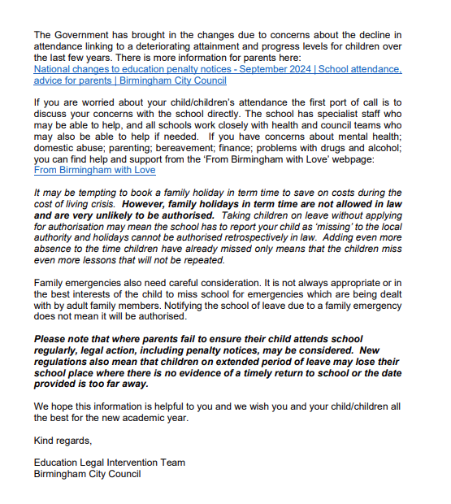

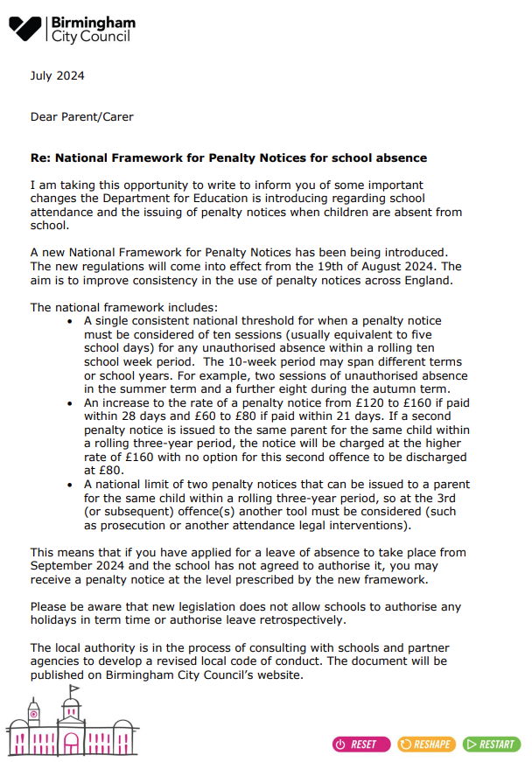

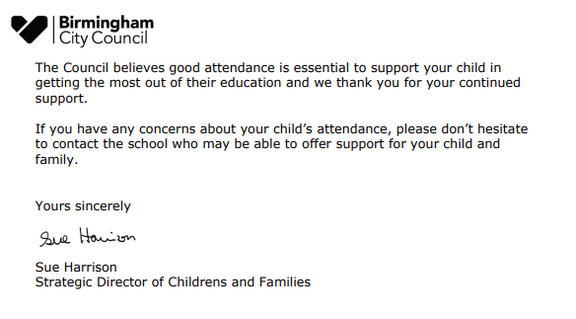

Leave of absence request form
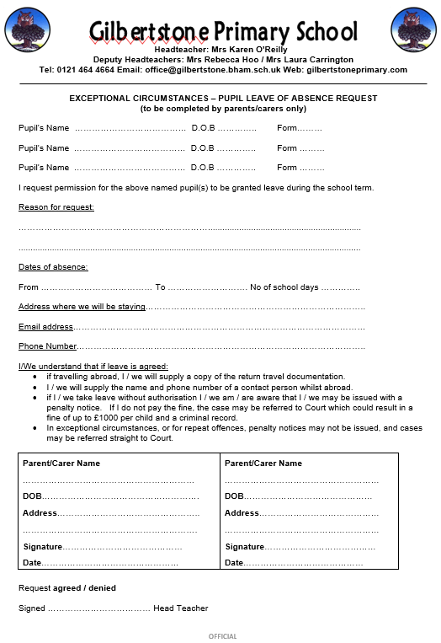

LD1
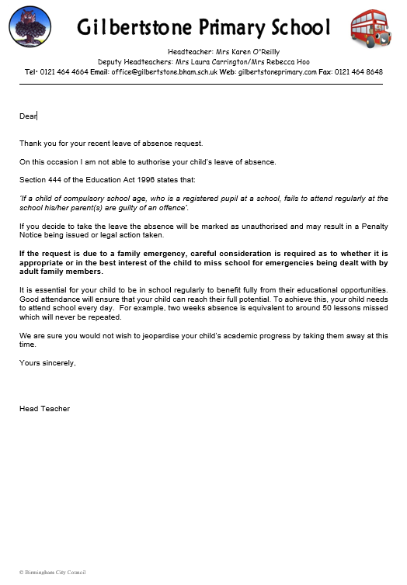

LD2
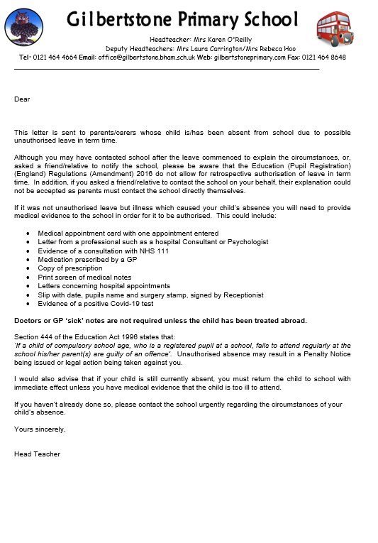

Medical evidence letter
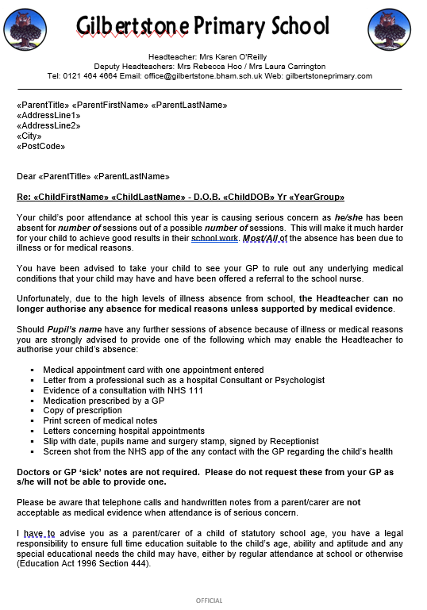

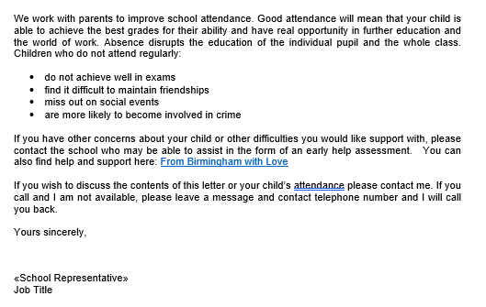

Head teacher letter of concern
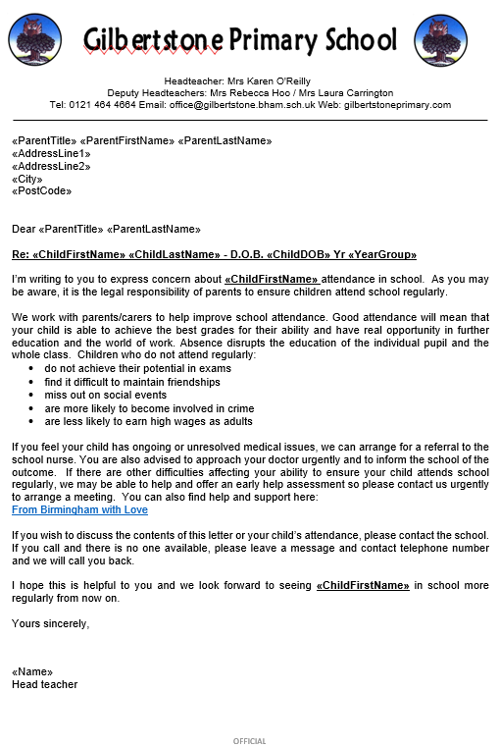

Punctuality letter
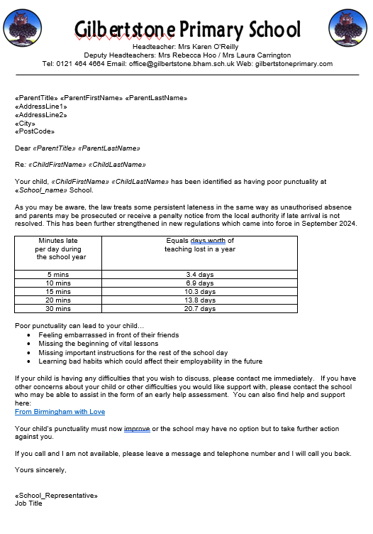

Reduced Timetable consent
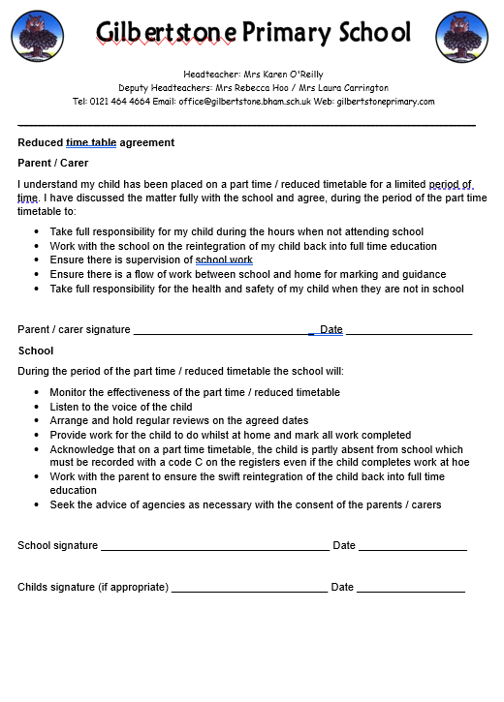

Glossary of Terms and Acronyms
Term | Meaning
Attendance Contract | A formal agreement between the school and parent/carer following a Formal Attendance Meeting.
CASS | Children's Advice and Support Service.
CPOMS | School’s welfare system
DfE | Department for Education.
DNA | Did not attend the meeting
DSL | Designated Safeguarding Lead.
EHA | Early Help Assessment. A structured assessment used to identify support needs.
EHCP | Education, Health and Care Plan.
Early Help | Support provided to children and families before difficulties escalate.
ELIT | Education Legal Intervention Team. Birmingham City Council's attendance enforcement team.
FAM | Formal Attendance Meeting.
FGB | Full Governing Body
FPN | Fixed Penalty Notice.
LA | Local Authority.
LOA | Leave of Absence.
NTI | Notice to Improve. A formal notice issued before a Penalty Notice may be considered.
PA | Persistent Absence. A pupil whose attendance falls below 90%.
RHRT | Right Help, Right Time. Birmingham's threshold document for support services.
SA | Severe Absence. Attendance of 50% or below.
SEND | Special Educational Needs and Disabilities.
SENDCo | Special needs coordinator (Mrs. Kane)

